EUROPEAN ASSOCIATION FOR CRANIO-MAXILLO-FACIAL SURGERY |  | 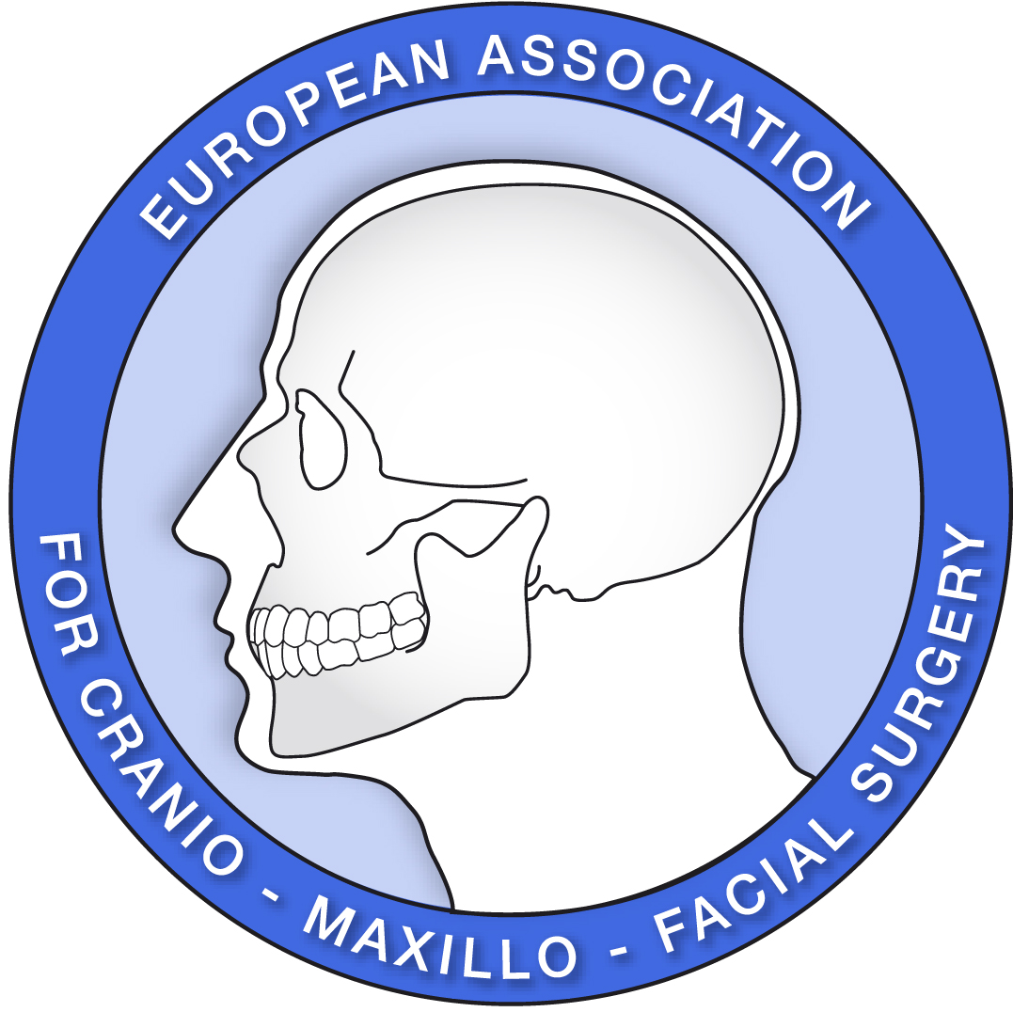

Operative Report Form
FACIAL COSMETIC SURGERY FELLOWSHIP

 |  | Name of patient | Birth date | Surgeon | Co-surgeon | Assistant-surgeon | Observed | Signature responsable surgeon
A | Traditional face lift (SMAS, deep plane,…)
 | Subperiosteal face lift
 | Endoscopic Facelift
B | Rhinoplasty
 | Septorhinoplasty
 | Septoplasty
C | Blepharoplasty (count bilaterals as 1 procedure only)
D | Facial Implants (e.g. malar)
 | Facial osteotomies (e.g. Le Fort, BSSO)
E | Otoplasty (#patients-not ears)
 | Other Auricular Revision
F | Coronal Frontal Lift
Browlift
Endoscopic Forehead Lift
G | Liposuction, complementary fat grafting
H | Scar Revision Surgery  Z-Plasty  W-Plasty/Geometric Broken Line Closure  Complex Other  Full Face
J | Skin resurfacing (chemical peel, laser, dermabrasion)
 | Tissue Expanders
K | Soft Tissue Augmentation (lipstructure, injectables)
Hair Replacement
Flap
Scalp Reduction
Micro, Mini or Punch Grafts
 | Total

