EUROPEAN ASSOCIATION FOR CRANIO-MAXILLO-FACIAL SURGERY |  | 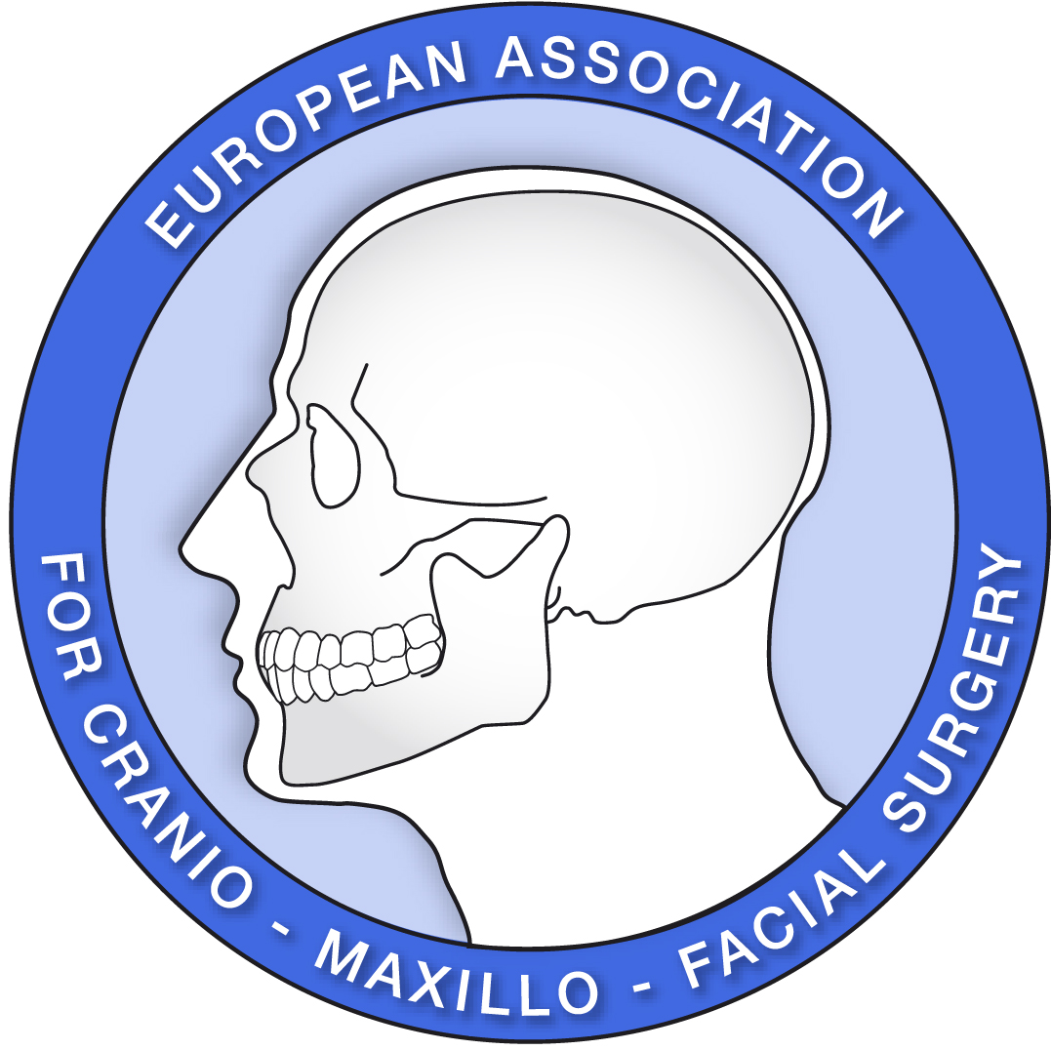

Operative Report Form

HEAD & NECK ONCOLOGY FELLOWSHIP

 |  | Name of patient | Birth date | Surgeon | Co-surgeon | Assistant-surgeon | Observed | Signature responsable surgeon
A | Neck Surgery (Misc.)
 | Selective neck dissection
 | Comprehensive neck dissection
B | Resection of malignant tumours
 | Excision of tongue/oro-pharyngeal tumour
 | Resection of mandible/maxilla
 | Orbital exenteration
 | Procedures for access to the skull base
C | Reconstruction
 | Harvest of non-vascularised extra-oral bone graft
 | Mandibular reconstruction with non-vascularised bone graft
Pedicled muscle/fascial/
myocutaneous flap
Vascularised free tissue transfer
Harvest of peripheral nerve (e.g. sural)
 | Facial nerve repair/graft
D | Salivary gland surgery
 | Excision of neoplasm of minor salivary gland
 | Sublingual gland excision
 | Submandibular gland excision
 | Partial/superficial parotidectomy
 | Total conservative parotidectomy
 | Radical parotidectomy
E | Osseointegrated implant surgery
 | Insertion of extra-oral implants/abutments
 | Insertion of intra-oral implants/abutments
 | Sinus lift/onlay graft
 | TOTAL

