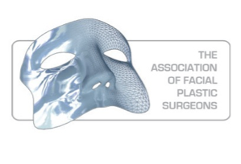

**Contents**

Pre-operative assessment

Patient preparation

Step-by-step guide to endoscopic brow lift

Step-by-step guide to lower blepharoplasty

Step-by-step guide to upper blepharoplasty

Step-by-step guide to facelift and necklift

Step-by-step guide to rhinoplasty

Step-by-step guide to otoplasty

Introduction to lasers

Postoperative Care

Complications

All procedures will be demonstrated on the cadaver and participants will have an opportunity to perform the procedure, one each side of the cadaver (2 candidates per cadaver).

Course Dinner will give an opportunity to meet and discuss your experience with the faculty.

**Facial Aesthetic Surgery Course**

(Fresh Cadaver Dissection Course)

19,20,21 March 2015

**Venue**

**Manchester Surgical Skills**

**& Simulation Centre**

The University of Manchester  
Stopford Building  
Oxford Road  
Manchester  
M13 9PT

**Faculty**

Prof V Ilankovan

Mr J Stanek

Mr B Musgrove

Mr T Mellor

Mr P Guest

Mr C Jones

Mr Saj Ataullah

**Course Organiser**

Mr B Musgrove

**The Association of Facial Plastic Surgeons**

Facial Aesthetic Surgery Course

19,20,21 March 2015

Application (Please print)

Name:……………………………………

Position:…………………………………

Hospital:…………………………………

Contact Details: (Address)………………………………………….……………

………………………………………………………

Telephone:………………………………………

E-mail…………………………………………………

I enclose a cheque for £……………………….

Signature…………………………….Date…………

The course fee is £900 (Including Course Dinner)

Please make cheques payable to:

**The Association of Facial Plastic Surgeons**

NB: Attendance is limited to 16 Delegates.

Applications, Cheques & Enquiries to:

**Mrs Eileen Arnal,Secretary to Mr B Musgrove**

**Russell House, Spire Manchester  
Whalley Range, Manchester,M16 8AJ**

[brian.musgrove@consultantcare.com](mailto:brian.musgrove@consultantcare.com)

**BACS Payment Details :**

**Branch Sort Code; 60.07.01**

**Account Number: 38064243**

**IBAN; GB 46 NWBK 600701 380 64243**

**Swift no; NWB KGB 21**

**Aim of the course**

The intention of this 3 day hands-on cadaver course is to teach surgical anatomy and the techniques for the commonly used facial cosmetic procedures

The dissection is performed on fresh frozen cadavers and allows each candidate to perform operations in an ideal setting.

A maximum of two candidates will be allocated to each cadaver.

The emphasis is placed on the ‘hands-on’ exercise. This will be demonstrated in a step-by-step explanation of several techniques prior to the operation.

The hands-on exercises are demonstrated in a well supervised environment by internationally renowned surgeons.

There will be opportunity to debate with the faculty and other delegates contentious issues in cosmetic surgery.

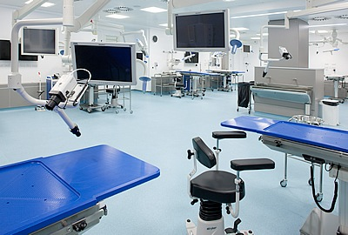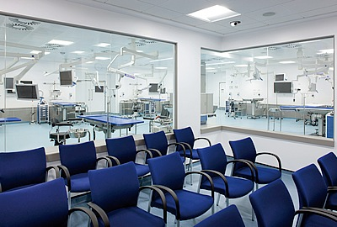

**Testimonials**

* Good CPD points, Good discussion at the end of course. Fantastic Faculty
* I feel the course was excellent both in the educational content, hands-on dissection, faculites and discussion. The variation in opinion as to each procedure reflected individual experience. I feel this should be strongly supported and ‘badged’ by BAOMS. (Mr B Evans).
* Overall a very good course, May be time for demonstration from faculty would be good. I liked that there was time for flexibility so we could explore areas we liked or wanted to know more about. I would recommend it to others.
* Overall an excellent course. Very good value for money. Excellent Faculty, Good facilities,Very highly recommended.

**The Venue**

The Manchester Surgical Skills and Simulation Centre has a unique integrated operating theatre environment with nine training stations featuring the latest in audio-visual technology and instrumentation made by world-renowned medical equipment manufacturers – identical to those you will find in the most advanced operating theatres in the world.