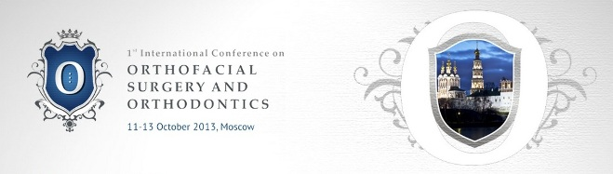
ORTHONEWS  ISSUE NO 1  2013 | INVITATION TO THE CONFERENCE  11 - 13 OCTOBER 2013  MOSCOW, RUSSIA
IN THIS ISSUE:  • Inside the ICOSO 2013  • Main topics  • Keynote speakers  • OrthoSage  • Venue  • Contacts | LATEST NEWS:  Meet the Scientific Faculty of ICOSO 2013!  OrthoSage - ask our Scientific Faculty a question!
INSIDE THE ICOSO 2013
The 1st International Conference on Orthofacial Surgery and Orthodontics (ICOSO) will be held in Moscow on 11-13 October 2013. This Conference is an excellent opportunity to profound ones knowledge both in practical and theoretical aspects, as event is structured of one day of master class and two days of conference.
In order to deliver the comprehensive knowledge, to introduce the latest techniques and share the professional experience the leading specialists in orthodontics, maxillofacial and oral surgery from Europe, Latin America, South Africa, and Russia will gather together to witness this world-scale event to be held in Russia for the first time! Contemporary approaches to the treatment of patients with dysgnathia and other skeletal abnormalities of face will be demonstrated by the means of in-depth presentations (the minimum duration of one lecture – 45 minutes) and live discussions after each session.
We encourage you to follow information at www.orthofacial2013.info or subscribe to the newsletter and receive latest news directly to your e-mail. Subscribe by e-mail info@orthofacial2013.info.
Your participation would be of greatest contribution to this event to enrich the professional society by sharing your knowledge and experience.
MAIN TOPICS
- Auxilary Plastic Surgery
- Coronoplasty as Final Approach after Surgery
- Orthodontic Preparation before and after Surgery
- Orthognathic Surgery Approaches
- Prosthodontic Dentistry
KEYNOTE SPEAKERS
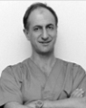 | Prof. Mirco Raffaini  (Italy)  Maxillofacial and Plastic Surgeon | 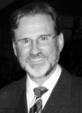 | Dr. Jorge Ayala Puente  (Chile)  Orthodontist
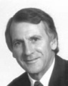 | Prof. Johan P. Reyneke  (South Africa)  Maxillofacial and Oral Surgeon | 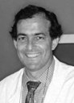 | Dr. Domingo Martin  (Spain)  Orthodontist
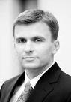 | Dr. Simonas Grybauskas  (Lithuania)  Maxillofacial and Oral Surgeon | 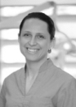 | Dr. Dalia Latkauskiene  (Lithuania)  Orthodontist
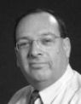 | Prof. Adrian W. Sugar  (United Kingdom)  Maxillofacial Surgeon | 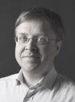 | Dr. Francesco Garino  (Italy)  Orthodontist
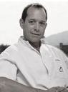 | Prof. Federico Hernandez-Alfaro  (Spain)  Maxillofacial and Oral Surgeon | 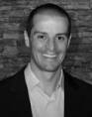 | Dr. Octavio Cintra  (Brazil)  Maxillofacial and Oral Surgeon
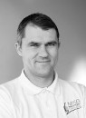 | Dr. Girts Salms  (Latvia)  Maxillofacial and Oral Surgeon |  | More information about the conference  is available on the official web site.  Please visit us at  www.orthofacial2013.info
ORTHOSAGE
If you have questions to members of our Scientific Faculty, please send it by e-mail info@orthofacial2013.info. We would appreciate if you would put under the subject "Question for speaker (indicating speaker's Name Surname)". Answers to questions will be announced in Conference website section OrthoSage and in Conference newsletter "OrthoNews".
VENUE
The Cosmos Hotel Moscow. Address: 150, Prospect Mira, Moscow, Russia.
It is located in the north-east Moscow on one of the city's major streets - prospect Mira, in green district, just 20 minutes drive to the centre. It is next to the All-Russia Exhibition Centre (V.V.C.), close to Ostankino Telecom Tower, Count Sheremetyev's Palace, "Olimpijsky" Sports Complex and "Sokolniki" Exhibition Complex. For more information press here.
 |  | CONTACTS  ICOSO 2013 Conference Secretariat  Live CO | Scientific Events Organizers  Tel. +370 689 07071  E-mail info@orthofacial2013.info  www.orthofacial2013.info
Copyright © ICOSO 2013
If you wish to cancel your subscription to this newsletter click here

