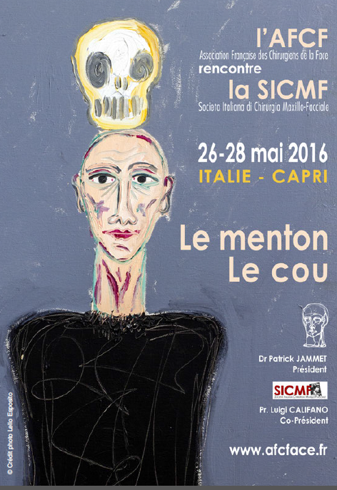
AFCF
(French Association of Facial Surgeons)
meets
SICMF
(Italian Society of Maxillo-Facial Surgeons)

on May 26 – 28 2016
in Capri – Italy

Theme:
The Chin
The Neck

Dr Patrick Jammet
President
Prof. Luigi Califano
Co-President
www.afcface.fr

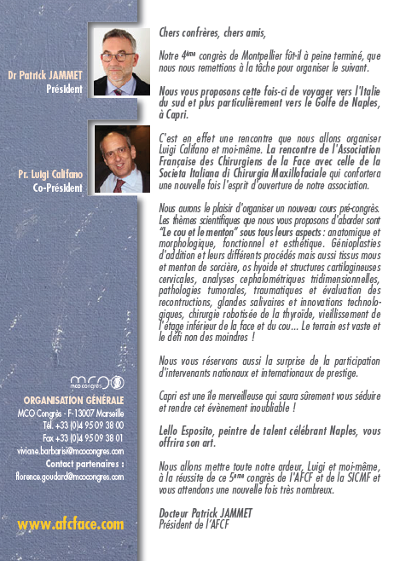
Dr. Patrick Jammet – President
Prof. Luigi Califano – Co-President
Dear Colleagues, Dear friends,
Our 4th Congress in Montpellier barely finished, we were already back to work for the organisation of the next one!
We now offer you to travel to southern Italy, towards the Gulf of Naples, to the wonderful island of Capri.
Prof. Luigi Califano and I are indeed organising a very special encounter. The encounter of the French Association of Facial Surgeons with the Italian Society of Maxillo-Facial Surgeons, thus underlining the spirit of openness of our Association.
We are furthermore delighted to organise a new pre-congress session.
The scientific themes which we intend to address are “The chin and the neck” in all their aspects: anatomical and morphological, function as well as aesthetic: augmentation genioplasties in all their diversity; soft tissue challenges such as the dropping chin; the hyoid bone and other cervical cartilaginous structures; 3D cephalometric analysis; tumoural or traumatic pathologies including reconstructive evaluation; salivary glands; technological innovations, robotic surgery of the thyroid gland; the ageing process of the lower face…. What a vast field and a daunting task!
We do intend to surprise you with prestigious national and international speakers.
Capri is a marvellous island which will undoubtedly thrill you and make this event unforgettable!
Lello Esposito, a talented painter from Naples will be sharing his art with you throughout the congress.
Luigi and I will do our utmost to make this joint AFCF/SICMF Congress a tremendous success and we look forward to welcoming you!
Dr. Patrick Jammet
President AFCF
---------------------
General Organisation:
Xxxxxxxxxxxxx

www.afcface.com

