Course includes

* Anatomy
* Assessment
* Closed Approach
* Open Approach
* Osteotomy
* Nasal Grafts
* Conchal Grafts
* Rib Grafts
* Tip Surgery
* Extracorporeal Septoplasty
* Face Lift/brow lift
* Local facial flaps
* Otoplasty
* Ethnic noses (Alar base reductions
* Nasal Reconstruction

**FUNCTIONAL SEPTORHINOPLASTY AND FACIAL PLASTICS COURSE**

**15-17 JUNE 2016**

**NEWCASTLE SURGICAL TRAINING CENTRE**

**Held at Newcastle Surgical Training Centre, the aim of this course is designed to facilitate the trainee surgeon with didactic and hands on cadaveric training experience.**

***“Superb supervision during dissection, amazing facilities”, June 2015***

**For more information:louise.sore@nuth.nhs.uk**

l

The Newcastle Surgical Training Centre is based at the Freeman Hospital, Newcastle upon Tyne. This 3 day highly supervised course offers the opportunity to learn and enhance skills in a range of Septorhinoplasty and Facial Plastic Surgery techniques on FRESH FROZEN CADAVERS. Applicants can take advantage of intensive cadaveric teaching from an expert faculty.

* An intensive course
* Number of attendees limited to 12
* Refreshments included
* Course certificate on completion
* Course dinner
* The course uses fresh frozen cadaveric specimens

**TARGET AUDIENCE**

ST3-ST8 and Consultants and Career Grade doctors wishing to update their skills

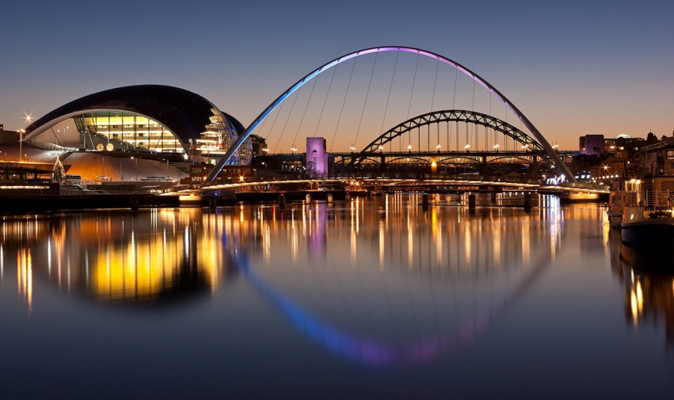

**For more information:louise.sore@nuth.nhs.uk**

l