

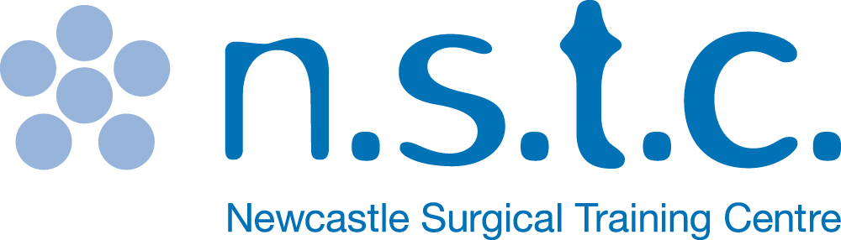

Application Form

Newcastle Head & Neck

Cadaver Course

3-5 May 2017

**Newcastle Surgical Training Centre** delivers over 150 advanced training courses from regional, national and international surgeons representing multi specialties. Collaboration with national and international faculty drives a greater understanding of surgical techniques delivering improved patient care.

**www.nstcsurg.org**

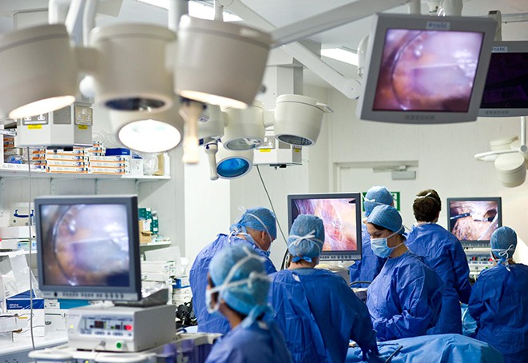

**www.nstcsurg.org**

**Newcastle Surgical Training Centre**

**FACULTY**

Mr Vin Paleri – Course Director

Mr Mani Ragbir (Plastics)

Additional faculty to be confirmed

Further information

For full details and registration information visit www.nstcsurg.org

Or contact: Louise Sore

Freeman Hospital, Newcastle upon Tyne

Tel: (+44) 191 213 8589

Email: louise.sore@nuth.nhs.uk

At the Newcastle Surgical Training Centre we are committed to giving you the best possible opportunities in education and training by offering a wide range of multidisciplinary courses to meet your every need. Our highly professional clinicians are here to train and support you every step of the way. Combining didactic teaching and practical procedures with leading edge technology, we offer first rate cadaveric training and continuing professional development in a purpose built facility. We also carry out pioneering research into new techniques and ensuring that you receive the very best surgical training available in the UK, both for today and in the future.

The Newcastle Surgical Training Centre is led by the co-directorship of Professor Alan Horgan and Professor David Deehan. The centre delivers over 150 advanced training courses from regional, national and international surgeons representing multi specialties. Collaboration with national and international faculty drives a greater understanding of surgical techniques delivering improved patient care.

About the centre

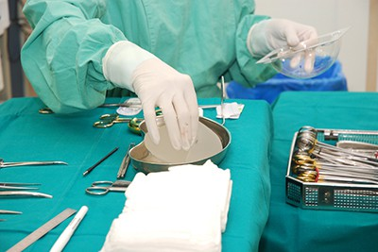

This course is designed to facilitate the trainee surgeon with didactic and hands on cadaveric training experience. Conducted by a faculty of experienced surgeons, this is an intensive two and a half day course of lectures, debate, exchange and practical hands on experience on Head and Neck dissection.

* An intensive course
* Number of attendees limited to 12
* Refreshments included
* Course certificate on completion
* Course dinner
* The course uses fresh frozen cadaveric specimens

**TARGET AUDIENCE**

ST3-ST8 and Consultants and Career Grade doctors wishing to update their skills

Course includes

* Tracheostomy
* Thyroid Lobectomy
* Medialisation Thyroplasty
* Submandibular Gland surgery
* Neck Dissection
* Parotidectomy
* Laryngeal Mobilisation and Laryngectomy/ TEP
* Mandibulotomy
* Pectoralis major
* Myocutaneous flap
* Deltopectoral flap
* Fibula osteocutaneous free flap
* Radial forearm free flap

**www.nstcsurg.org**

**Newcastle Surgical Training Centre**

Course overview

Application Form

NEWCASTLE HEAD AND NECK CADAVER COURSE

Date:

3-5 May 2017 (3 days)

|  |  |  |  |
| --- | --- | --- | --- |
|  | | | |
| **DISSECTOR FEE**: | £895 |  |  |
|  |  |  |  |
|  |  |  |  |

|  |  |
| --- | --- |
| Your details | |
| Surname: | Title: (Mr / Mrs / Miss / Ms ) |
| Forenames: | |
| Job Title: | Department: |
| Hospital Address: |  |
|  | Postcode: |
| Mobile Telephone: | Email: |

|  |
| --- |
| Further details |
| How did you hear about this course? Trust Website Mailing Other |
|  |
| Please state any special dietary requirements: |
|  |
|  |
|  |
| Please state to whom invoices should be addressed, if no alternative contact is given, all invoices  will be directed to the applicant |

|  |  |
| --- | --- |
| Declaration | |
| Signed: | Date: |

**OBSERVER FEE** £200

Course title:

     

     

     

**Please note:** The course fee will include: lunch and refreshments. Payment can be made via BACS (automatic bank transfer) by Credit Card, or by cheque payable to **Newcastle upon Tyne Hospitals NHS Trust.** Full details and registration information at [www.nstcsurg.org](http://www.nstcsurg.org) Please note payment is due at registration to secure your place. Attendance on the course is conditional upon advance payment being received. Refunds cannot be given in the event of your cancellation within two weeks of the course date. The NSTC cannot accept liability for costs incurred in the event of a course having to be cancelled as a result of circumstances beyond its reasonable control. There is an administration charge of 10% (or £50, whichever is greater) of the total course fee. However, within four weeks prior to the start date of the course, the total course fee will be charged unless in exceptional circumstances at the discretion of the NSTC.

While we make every effort to run courses as advertised, we reserve the right to change the timetable and/or the teaching staff without prior notice and to cancel any courses without liability (in which case there will be a full refund of course fees to participant). Note that any consequential losses (e.g. travel or accommodation costs) incurred in such cases remain the responsibility of the booker, and consideration should be made to taking out appropriate travel insurance for any non-refundable costs.

     