

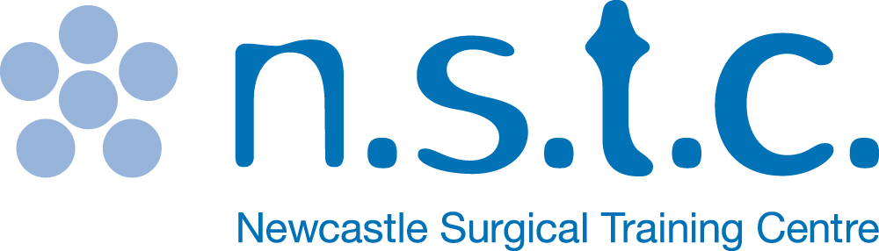

**THE 3rd UK TRANSORAL ROBOTIC SURGERY**

**CONFERENCE AND CADAVERIC HANDS ON**

**DISSECTION COURSE**

**5th & 6th APRIL 2017**

**NEWCASTLE SURGICAL TRAINING CENTRE**



|  |  |  |  |
| --- | --- | --- | --- |
| [Image result for da vinci robot pictures](http://www.google.co.uk/url?url=http://www.intuitivesurgical.com/company/media/images/davinci_si_images.html&rct=j&frm=1&q=&esrc=s&sa=U&ved=0ahUKEwj386WcmIXQAhXEBsAKHScuAQQQwW4IGDAB&usg=AFQjCNEX9FZBWFtJXMFgxmTi3cQvdi2qYA) | [Image result for da vinci robot pictures](http://www.google.co.uk/url?url=http://intuitivesurgical.com/company/media/images/singlesite.html&rct=j&frm=1&q=&esrc=s&sa=U&ved=0ahUKEwiKwIWQmYXQAhWEC8AKHcf9DJ04FBDBbgggMAU&usg=AFQjCNHQBP4qm82CdY5gNhtN75zsgPj65A) | [Image result for da vinci robot pictures](http://www.google.co.uk/url?url=http://www.davincisurgery.com/da-vinci-surgery/da-vinci-surgical-system/&rct=j&frm=1&q=&esrc=s&sa=U&ved=0ahUKEwj386WcmIXQAhXEBsAKHScuAQQQwW4IFjAA&usg=AFQjCNFIJr-mEFMz9WMsmiDJFVuDqLBdfA) | [Image result for da vinci robot pictures](http://www.google.co.uk/url?url=http://robocatz.com/daVinci-surgical.htm&rct=j&frm=1&q=&esrc=s&sa=U&ved=0ahUKEwj386WcmIXQAhXEBsAKHScuAQQQwW4IIDAF&usg=AFQjCNH8DghyBvB3fSprDYHSYgbCs7kJqQ) |

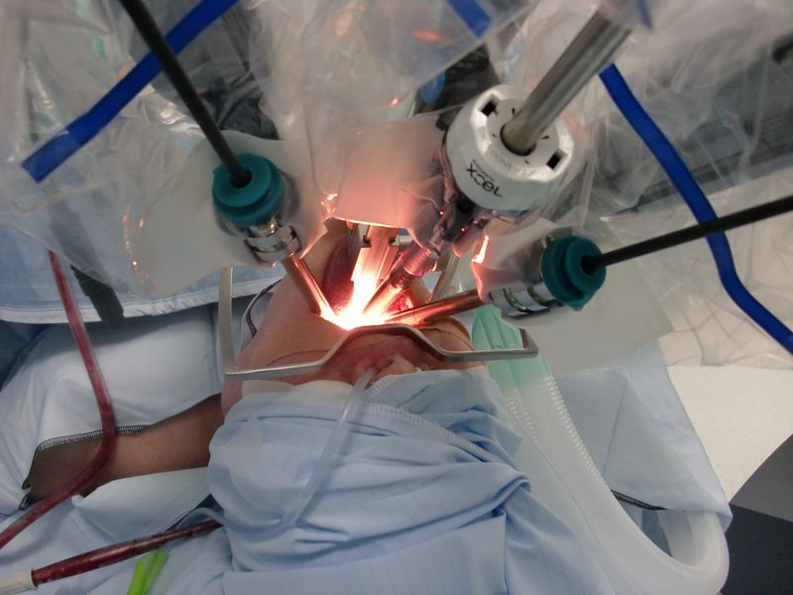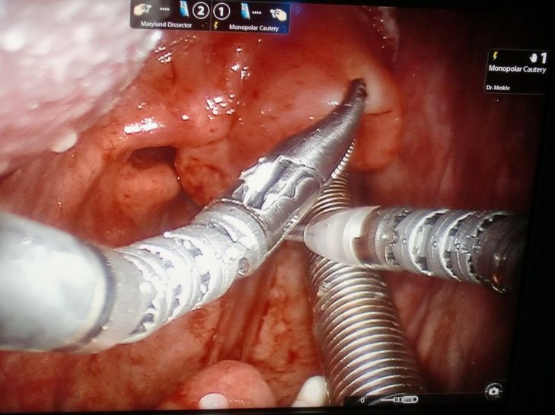[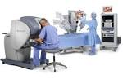](http://www.google.co.uk/url?url=http://womenshealthfoundation.org/2014/02/28/da-vinci-remove-uterus/&rct=j&frm=1&q=&esrc=s&sa=U&ved=0ahUKEwj386WcmIXQAhXEBsAKHScuAQQQwW4IGjAC&usg=AFQjCNFV87JhXvK3ynCjtrRLKt6i8xvg7Q)

CPD APPROVED BY ENT UK

**Newcastle Surgical Training Centre** delivers over 170 advanced training courses from regional, national and international surgeons representing multi specialties. Collaboration with national and international faculty drives a greater understanding of surgical techniques delivering improved patient care.

**www.nstcsurg.org**

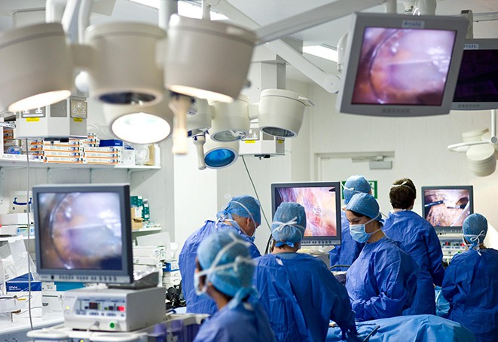

**FACULTY**

Professor Vinidh Paleri – Course Director

Dr Ahmed Chishti, Newcastle

Mr Mriganke De, Derby t/c

Dr Charles Kelly, Newcastle

Mr David Meikle, Newcastle

Mr Enyi Ofo, London t/c

Mr James O’Hara, Newcastle

Ms Sarah Owen, Newcastle

Dr Jo Patterson, Sunderland

Mr Andrew Robson, Cumberland

Mr Philip Ralph, Intuitive Surgical

Professor Naeem Soomro, Newcastle

Mr Max Robinson, Newcastle

Mr Russell Watkins, Newcastle

Mr Stuart Winter, Oxford t/c

INTERNATIONAL FACULTY MEMBER:

TO CONFIRM

**TARGET AUDIENCE:**

**Senior Head and Neck Trainees/Consultants**

Further information

For full details and registration information visit www.nstcsurg.org

Or contact: Louise Sore

Freeman Hospital, Newcastle upon Tyne

Tel: (+44) 191 213 859

Email: louise.sore@nuth.nhs.uk

At the Newcastle Surgical Training Centre we are committed to giving you the best possible opportunities in education and training by offering a wide range of multidisciplinary courses to meet your every need. Our highly professional clinicians are here to train and support you every step of the way. Combining didactic teaching and practical procedures with leading edge technology, we offer first rate cadaveric training and continuing professional development in a purpose built facility. We also carry out pioneering research into new techniques and ensuring that you receive the very best surgical training available in the UK, both for today and in the future.

The Newcastle Surgical Training Centre is led by the co-directorship of Professor Alan Horgan and Professor David Deehan. The centre delivers over 150 advanced training courses from regional, national and international surgeons representing multi specialties. Collaboration with national and international faculty drives a greater understanding of surgical techniques delivering improved patient care.

**www.nstcsurg.org**

**Newcastle Surgical Training Centre**

About the centre



This course is designed to facilitate the surgeon with didactic and hands on cadaveric training experience. Conducted by a faculty of experienced surgeons, this is an intensive two day course of lectures, debate, exchange and practical hands on experience on TORS procedures using an XI

Da Vinci Robot.

**A two day intensive course**

**Number of Dissectors limited to 8**

**DISSECTORS – Will have full access to the Da Vinci Robot with Hands on Procedures and attendance to the Clinical Lectures**

**30 NON DISSECTOR Places only –**

**Non Dissectors will have full access to the Clinical Lectures only**

**Refreshments included**

**Course certificate on completion**

**Course dinner**

**The course uses fresh frozen cadaveric specimens**

Upon registration, you will be required to complete an online registration and complete some online modules. This will not only register you as a robotic surgeon to be trained, but will also gain you access to procedure videos and clinical data. The modules will take (1-2 hours) this is a pre requisite of the course, you will be required to complete this assessment

Details on how to complete the online modules will be issued nearer the course date.

Course Objectives

NON DISSECTORS – Clinical Lectures only

* Define the role of transoral robotic surgery in current day head and neck cancer practice
* Appreciate the strengths and weaknesses of the evidence base in this emerging field
* Share best practice on setting up a robotic surgery programme
* Understand the benefits and rationale of offering a transoral resection service
* Gain an insight into the pathological assessment of transoral resections
* Understand the adjuvant treatment schedule following transoral surgery

DISSECTORS – Full access to the Da Vinci Robot – with hands on procedures on fresh frozen cadavers and full access to the clinical lectures

* Become familiar with the function and operation of the da Vinci Surgical System
* Appreciate the ergonomics of the da Vinci Surgical system robot and the available robotic instrumentation
* Understand the selection process for patient position, da Vinci surgical team position and robotic surgical approaches
* Learn robotic tissue dissection techniques using monopolar energy

**CPD APPROVED by ENT UK**

**www.nstcsurg.org**

**Newcastle Surgical Training Centre**

Course Overview

Application Form

: **THE 3rd UK TRANSORAL ROBOTIC SURGERY**

**CONFERENCE AND CADAVERIC HANDS ON**

**DISSECTION COURSE**

|  |  |  |  |
| --- | --- | --- | --- |
| 5th & 6th April 2017 | | | |
| **DISSECTOR FEE**: | £ 975.00 |  |  |
|  |  |  |  |
|  |  |  |  |

|  |  |
| --- | --- |
| Your details | |
| Surname: | Title: (Mr / Mrs / Miss / Ms ) |
| Forenames: | |
| Job Title: | Department: |
| Hospital Address: |  |
|  | Postcode: |
| Mobile Telephone: | Email: |

|  |
| --- |
| Further details |
| How did you hear about this course? Trust Website Mailing Other |
|  |
| Please state any special dietary requirements: |
|  |
|  |
|  |
| Please state to whom invoices should be addressed, if no alternative contact is given, all invoices  will be directed to the applicant |

|  |  |
| --- | --- |
| Declaration | |
| Signed: | Date: |

**NON DISSECTOR FEE** £275.00

     

     

     

**Please note:** The course fee will include: Dinner, Lunch and efreshments. Payment can be made via BACS (automatic bank transfer) by Credit Card, or by cheque payable to **Newcastle upon Tyne Hospitals NHS Trust.** Full details and registration information at [www.nstcsurg.org](http://www.nstcsurg.org) Please note payment is due at registration to secure your place. Attendance on the course is conditional upon advance payment being received. Refunds cannot be given in the event of your cancellation within two weeks of the course date. The NSTC cannot accept liability for costs incurred in the event of a course having to be cancelled as a result of circumstances beyond its reasonable control. There is an administration charge of 10% (or £50, whichever is greater) of the total course fee. However, within four weeks prior to the start date of the course, the total course fee will be charged unless in exceptional circumstances at the discretion of the NSTC.

While we make every effort to run courses as advertised, we reserve the right to change the timetable and/or the teaching staff without prior notice and to cancel any courses without liability (in which case there will be a full refund of course fees to participant). Note that any consequential losses (e.g. travel or accommodation costs) incurred in such cases remain the responsibility of the booker, and consideration should be made to taking out appropriate travel insurance for any non-refundable costs.

     