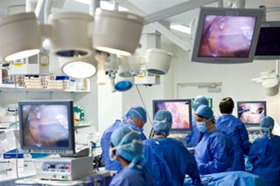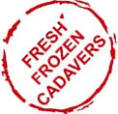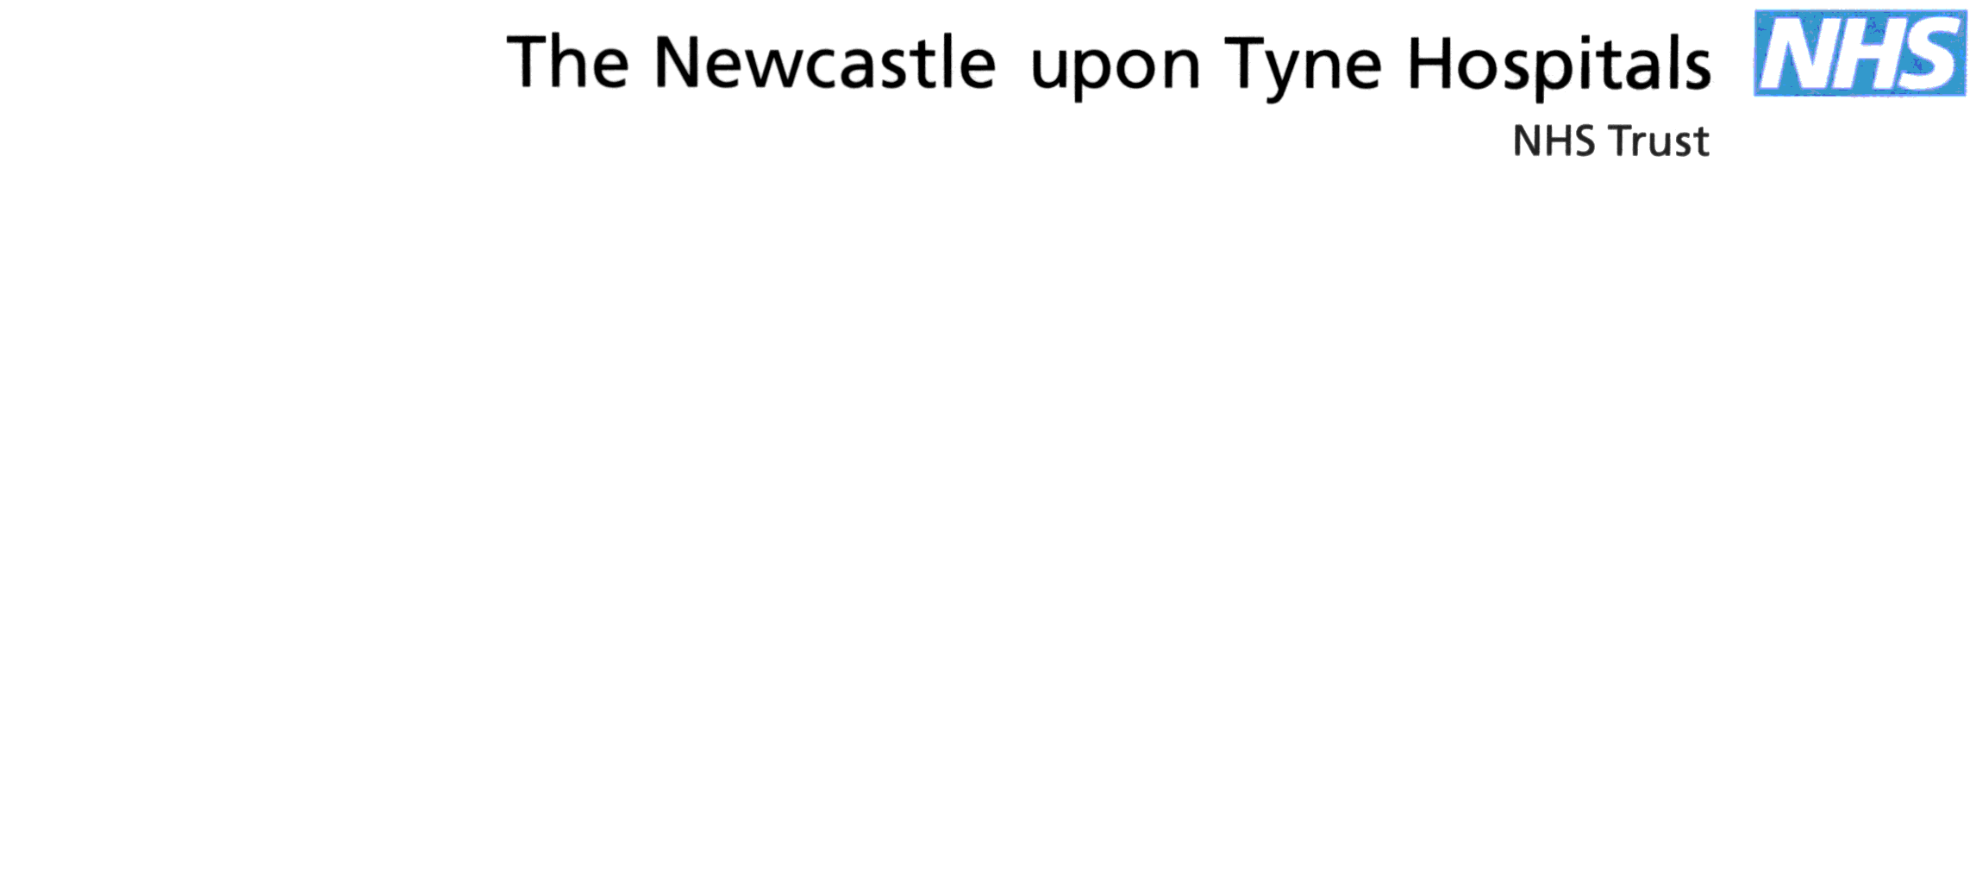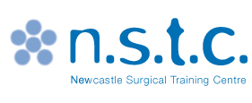

**Faculty**

Mr Peter Hodgkinson - Consultant  
Mr David Sainsbury – Consultant

Mr Alistair Smyth – Consultant   
Ms Jacqueline Miller - Speech and Language Therapist  
Dr Sophie Butterworth- Junior cleft fellow

**Maximum of 8 delegates**

**Educational Aims of the Course:**

* **Develop and enhance anatomical knowledge**
* **Understanding of Specialist Instrumentation**
* **Methodical Dissections**
* **Surgical Procedures to manage complications**

This is an intensive one day course with an expert faculty. A series of didactic lectures and edited videos provides step by step tuition covering the speech surgery curriculum.

* Experts on the subject will present the anatomical and technical aspects of procedures along with risks, benefits and outcomes.
* Teaching is through cadaver dissection and you will have **HANDS ON** practical dissection on **FRESH FROZEN** specimens
* Procedures delivered are:

Intravelar veloplasty  
 Hynes Pharyngoplasty  
 Buccal flap

FAMM flap

Furlow's Palatoplasty

**For more information please contact**

**Louise Sore**

**Newcastle Surgical Training Centre, Freeman Hospital**

**Tel: 0191 213 8589 Email: louise.sore@nuth.nhs.uk**

**www.nstcsurg.org**

**NEWCASTLE SURGICAL TRAINING CENTRE**

**CADAVERIC SPEECH AND PALATE SURGERY COURSE**

**25 November 2019 Registration fee: £495**

This course is designed for ST5-ST8 trainees who are interested in the most recent developments in Plastic Surgery, ENT and OMFS.